Observation of Sociability Behavior in Famous Las Vegas Sign

Name
Institution
Course
Instructor
Date

Observation of Sociability Behavior in Famous Las Vegas Sign
Observation Background
Famous Las Vegas Sign is among the well-recognized historical landmarks developed in 1959. The park has a sign with the words “Welcome to Fabulous Las Vegas sign” and is established in the median at 5100 Las Vegas Boulevard South. Individuals can easily visit the park because of its fascinating location, which is outside the city restrictions. Therefore, I observed the park for thirty minutes from 22:00 to 22:30 on 11th October 2021. Coronavirus pandemic has adversely affected individuals’ sociability status; however, the group that knows each other still interacts and communicates closely without social distance, which could increase the spread of the virus.
The behavior selected to observe is sociability because of the coronavirus pandemic; the behavior was essential in understanding how individual social status is affected. Operation definition: sociability is the tendency of individuals to be cooperative with others, go out with friends and have fun. Individuals behave socially through involvement in certain activities and events that make them happy and feel concerned and empathetic. The reason for selecting sociability behavior is because the majority of the individuals that come to the park always come to have fun by taking photographs and enjoying with their friends. This is through creating memories together.
Coronavirus pandemic increased tremendously in early 2020. Therefore, Zuo et al. (2020) performed a study to understand the effects of the pandemic on the mobility and sociability of individuals. The authors analyzed data from cities like New York City and Seattle because the coronavirus had already hit them. The data indicates that the transport industry and individuals’ socialization is highly affected because of the restrictions set, such as social distancing to reduce the spread of the virus (Zuo et al., 2020). I quantified the behavior based on how individuals take photos and how different groups interact and communicate while in the park. For example, four groups of people interacted closely and took a picture together during the thirty minutes. Only one woman was carried by a man when taking a shot during the thirty minutes. Different groups that came separately interacted alone without other groups. The study hypothesis is the virus has significant effects on individuals’ sociability behavior.
Observation Field Notes
- 22:00 Three individuals enter the Las Vegas sign with a female taking both male and female photos. [the two looked as they were couples and enjoyed the park]
- 22:03 A young man enters the park, and a lady follows. The man runs towards the sign as he holds his hands up.
- 22:05 Both the two individuals and the other initial group are viewing the photos on their phones independently. They seem to communicate and laugh, but they do not interact with each group.
- 22:10 Another two groups come into the park. The first group comprises three men and a woman, and the second group shall consist of two males, three females, and a child. [ the first groups seem to have friends, and the second group appears to comprise family members. Each group is independent because they enter the park differently and do not communicate with each other but themselves]
- 22:15 the group with the child are taking a selfie and standing close to each other. However, other groups are differently situated with distance among them.
- 22:17 The first group leaves the park.
- 22:22 A female runs to the sign while the hands are up. Two males follow her, and they stand in front of the sign. The female is between the two males, and they pose for a photo. The third male individuals go close and kneel to take a photo using his phone.
- 22:25 After several photos are taken, the four individuals converge and start seeing the picture. The female jumps up and holds one of the males close to her while laughing. [ the lady seems to be excited to see her photos in the park and with the friends]
- 22:28 Three groups leave the park. Another group comes in with two men and a woman.
- 22:29 A male and a female close to the sign. The man carries the lady, and the third person takes a photo using their phone.
- 22:30 The group sees the photo together and then leaves the park.
- Observational Results
- Based on the observation, I found out that individuals increased their interaction among themselves. The group that knew each other and came out together socialized and had fun together. Some even raised their hands and jumped up to get a better picture. Also, the couples had a good experience in park. However, the different groups did not interact efficiently. I concluded that people are still afraid of the virus and fear interacting with other groups they do not know. However, I believe the vaccines have allowed people to socialize because they can slightly come out to the sign together. I have confirmed the hypothesis that the virus affects individuals' socialization; as the webcam shows, the majority of the individuals seem to have limitations in their interaction. The observation went well because I had a good internet connection, and the webcam was well visible and indicating the timestamp. I was able to pause the video and record my observation effectively and continue with the video again.
References
EarthCam. (n.d). Welcome to Fabulous Las Vegas. https://www.earthcam.com/usa/nevada/lasvegas/?cam=sign_hd
Zuo, F., Wang, J., Gao, J., Ozbay, K., Ban, X. J., Shen, Y., ... & Iyer, S. (2020). An interactive data visualization and analytics tool to evaluate mobility and sociability trends during covid-19. arXiv preprint arXiv:2006.14882.

Appendix
- Individuals interact together while taking pictures.
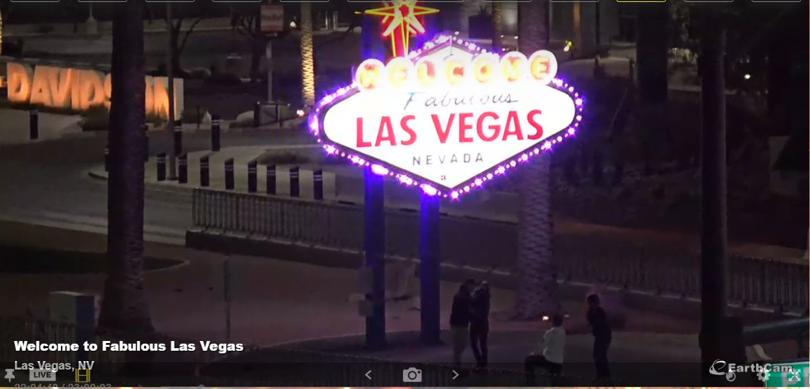
- More groups come in and interact
